Vision Document

**Software Design & Analysis**

Course Instructor

Pariwish Touseef

Submitted By

Zain Ul Abideen,Arqam Aleem,Ahmed Raza

Section

5C

Roll No

20F-0277,20F-0109,20F-0358

Date

**Saturday, September 10, 2022**

FALL 2022



**Department of Computer Science**

FAST – National University of Computer & Emerging Sciences

Chiniot-Faisalabad Campus

Contents

1 Document Version 3

2 Introduction 3

**3 Business Opportunity** 3

4 Problem Statement 4

5 Summary of Features 5

5.1 self-pickup 5

5.2 Google Map integration 5

5.3 Online Payment Method 5

**5.4 Security** 5

**5.5 Option for Quick Delivery** 5

6 Product/Service Overview 5

7 Dependencies and Constraints 5

8 Cost and Pricing 5

9 Licensing and Installation 6

# 1 Document Version

|  |  |  |  |
| --- | --- | --- | --- |
| **Version** | **Date** | **Description** | **Authors** |
| V1.0 | 10 September 2022 | Initial Vision Document | ZAIN UL ABIDEEN,Arqam,Ahmed Raza |
| V2.0 |  | Refined Vision Document |  |

# 2 Introduction

**2.1 Purpose**

The purpose of this document is to collect, analyze, and define high-level needs and features of the **FOOBREX LOGISTICS –** Cargo and Logistics management system.

**FOOBREX LOGISTICS** focuses on the capabilities needed by the customers and administration of the logistics company and to make secure and reliable resource of sending the goods and to avoid any misunderstandings.

**2.2 Definitions, Acronyms, and Abbreviations**

**FOOBREX LOGISTICS –** Cargo and Logistics management system.

**2.3 References**

TBD.

# **3 Business Opportunity**

Software is necessary tool for the logistic company as it has to be saved the records of goods that enters the warehouses. As all system become online so no need for the customers to go out for the logistics company.

In order to facilitate the customers and to avoid any conflict we will be providing the software that will resolve all the problems.

Sales will also be increased through this process

# 4 Problem Statement

|  |  |
| --- | --- |
| **Problem** | **Description** |
| THE PROBLEM OF | * Security of Products * Unavailability of cash at time of receiving * Ambiguity of customer regarding delivery of cargo e.g. receiving date/time, or place of product. |
| AFFECTS | Customer  Administration |
| The Result of which | **Customers:**  Misplacement or damage of product.  The unregistered person for receiving hand may receive the product.  Cash unavailability can cause issue for person receiving the product.  **Administration:**  Conflict with customers.  Breakdown of Record at the warehouse.  Receiving multiple queries by customers which can result in distraction from main work. |
| Benefits | * Parcel will be delivered in a more efficient way. * Safety of product will be enhanced. * Live tracking of parcel will provide solution to ambiguities of customers regarding receiving date/time or venue. |

# 5 Summary of Features

## 5.1 self-pickup

We will be providing the feature of self-pick up where at the start our system will ask about the option. If self-pickup selected, then we will cost them less.

## 5.2 Google Map integration

The google map will be integrated into our system for live tracking of the riders

## 5.3 Online Payment Method

Our System will be integrated with all the local and international payments methods such as

Jazz cash, easy-paisa, sadapay,nayapay etc.

## **5.4 Security**

Whenever user login the account a notification will be provided to him.

## **5.5 Option for Quick Delivery**

Our system will provide the option for the quick delivery of goods where we will charge extra money from the customer.

# 6 Product/Service Overview

Every time when the customer wants send his/her goods we will provide them insured and secure environment until the product reaches the destination

# 7 Dependencies and Constraints

Security for website and app includes authentication, access control, data integrity, OTP confirmation and data privacy.

Authentication for user includes face detection and password that is given to the user.

There is a subclass of Admin module that includes riders and riders are restricted to use some features of App for example (Riders don’t know the OTP which is sent to customer for verification at time of delivering the parcel).

Some constraints are placed against hacking. If the user ever gets scammed then he should contact with the security team with his email. For example, if some other guy knows his user login id and password then he can get help from Admin.

# 8 Cost and Pricing

|  |  |  |  |
| --- | --- | --- | --- |
| Item | No of Items | Cost | Total |
| App Developer | 1 | 30000 |  |
| Web Developer | 1 | 30000 |  |
| Web hosting+Domain | ____ | 10000 |  |
| Others | 0 | 10000 | 80000 |

# 9 Licensing and Installation

The licensing is being verified by Google play store and app will be available for free. For installation go to play store and click on install then login your id and password. Secondly on browser open it though by website link.

**3) Architecture Diagram**

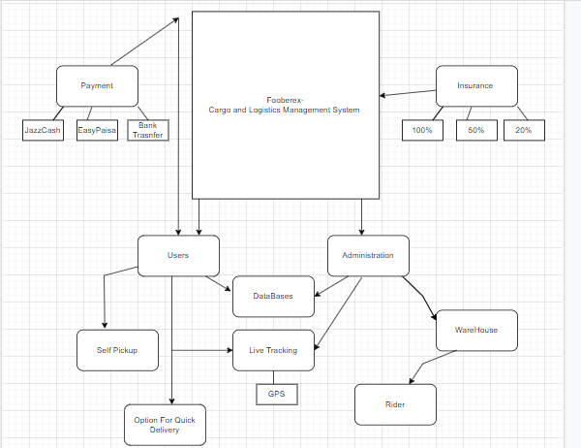

.

**4) Use Case Diagram**

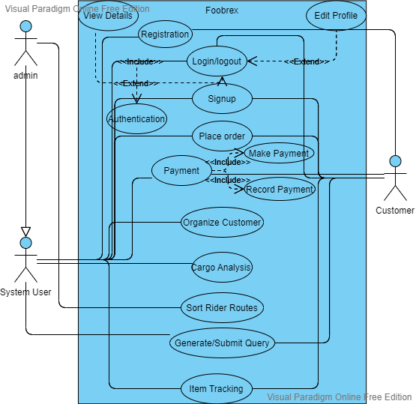

**5) Use case Specification (Textual Use Cases)**

**Brief Use Cases:**

|  |  |
| --- | --- |
| **Use case** | **Organize Customer** |
| **Actors** | **Admin, System User** |
| **Type** | **Primary** |
| **Description** | **Customers details and their related orders data could be organized.** |

|  |  |
| --- | --- |
| **Use case** | **Registration** |
| **Actors** | **Admin, System User, Customer** |
| **Type** | **Primary** |
| **Description** | **A person can come and register himself/herself if he/she is a new user.** |

|  |  |
| --- | --- |
| **Use case** | **Cargo analysis** |
| **Actors** | **Admin** |
| **Type** | **Primary** |
| **Description** | **Cargo details such as departure/destination terminal etc. could be organized or analyzed for keeping and updating record for better working.** |

|  |  |
| --- | --- |
| **Use case** | **Sort Rider routes** |
| **Actors** | **Admin** |
| **Type** | **Primary** |
| **Description** | **Rider routes will be sorted by selecting the best algorithm for sorting their routes.** |

|  |  |
| --- | --- |
| **Use case** | **Login/Logout** |
| **Actors** | **Admin, System User, Customer** |
| **Type** | **Primary** |
| **Description** | **Customer can login and logout to verify the users information and will allow them to use the system features according to user type if their login info is authenticated.** |

**Fully Dressed Use Cases:**

|  |  |
| --- | --- |
| **Use case Name** | **Item Tracking** |
| **Use Case ID** | **01** |
| **Description** | **Item can be tracked and one can get it’s live location** |
| **Primary Actors** | **Admin, system users** |
| **Secondary Actors** | **Customer** |
| **Preconditions** | **Item Order should be placed and ready for departure** |
| **Main Flow** | **Item will be given a tracking ID. Tracking ID will be entered on the system to get info of item.** |
| **Post conditions** | **Item details including live location is displayed.** |
| **Alternative Flows** | **If tracking ID entered is wrong or entered of another item details can be ambiguous.**  **If system is overloaded or database is down it can result in failure of this use case.** |

|  |  |
| --- | --- |
| **Use case Name** | **Place Order** |
| **Use Case ID** | **02** |
| **Description** | **Item can be tracked and one can get it’s live location** |
| **Primary Actors** | **Customer** |
| **Secondary Actors** | **System User, Admin** |
| **Preconditions** | **Item should be ready for placing order.** |
| **Main Flow** | **Customer has to select the type of item for placing its order. Then information about receiving end etc. should be provided. After that customer will be asked about receiving of parcel from home by a rider or not.** |
| **Post conditions** | **After submit button is pressed order will be placed.** |
| **Alternative Flows** | **If Customer has entered some wrong information or database is down so it may result in ambiguous result.** |

|  |  |
| --- | --- |
| **Use case Name** | **Generate/Submit Query** |
| **Use Case ID** | **03** |
| **Description** | **This use case will get queries of customers which will be processed by customer users** |
| **Primary Actors** | **Customer** |
| **Secondary Actors** | **System User, Admin** |
| **Preconditions** | **Item’s order is processed or in state of processing.** |
| **Main Flow** | **Customer can have an issue regarding his parcel delivery which can be resolved by getting into communication with system users. Customer can Question service providers about their queries. Customer could write a query in chat box and press the send button.** |
| **Post conditions** | **After submit button is pressed query will be sent to system users.** |
| **Alternative Flows** | **If database is down so it may result in ambiguous result.** |

|  |  |
| --- | --- |
| **Use case Name** | **Payment** |
| **Use Case ID** | **04** |
| **Description** | **Item’s charges will be given and received by admins.** |
| **Primary Actors** | **Customer** |
| **Secondary Actors** | **Admin, System User** |
| **Preconditions** | **Order should be placed.** |
| **Main Flow** | **After order is placed customers will get an invoice according to their order. Option of payment method will be displayed e.g, through easypaisa, jazz cash, or any other banking app or in cash. This information will be stored in database by admin or system user. After transaction is completed a pop up message will be displayed for greetings.** |
| **Post conditions** | **Payment of defined product is done.** |
| **Alternative Flows** | **If paying through card or any other banking app data base of them may crash. Customer can enter wrong MPIN or he/she may be out of cash.** |

**6)System Sequence diagram**

**Sequence system Diagram**

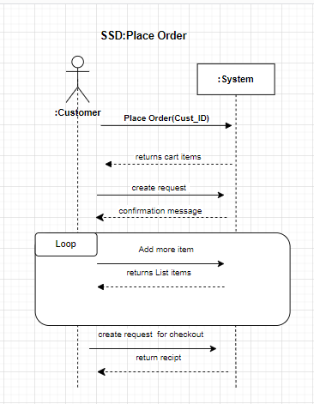

**7)Operational Contracts**

|  |  |  |
| --- | --- | --- |
| **Contract Name:** Place Order | | |
| **Operation:** | placeorder(cust_id) |
| **Cross References:** | Use Case: Place order |
| **Preconditions:** | Customer must login into the system |
| **Postconditions:** | * A placeorder instance po was created (instance creation) * po was associated with current order (association formed) * po.details became details (attribute modification) * po was associated with a customer, based on cust_id match (association formed) |

|  |  |  |
| --- | --- | --- |
| **Contract Name:** Track Item | | |
| **Operation:** | trackitem(trackingid) |
| **Cross References:** | Use Case: Track Item |
| **Preconditions:** | Customer must login into the system |
| **Postconditions:** | * A trackitem instance ti was created (instance creation) * ti was associated with current item (association formed) * ti.location became location(attribute modification) * ti was associated with a rider, based on trackingid match (association formed) |

|  |  |  |
| --- | --- | --- |
| **Contract Name:** Submit Query | | |
| **Operation:** | InitailizeQuery(user_id) |
| **Cross References:** | Use Case: Submit Query |
| **Preconditions:** | Customer must login into the system |
| **Postconditions:** | * A InitailizeQuery instance iq was created (instance creation) * iq was associated with current query (association formed) * iq.cust_id became cust_id(attribute modification) * iq was associated with customer, based on cust_id match (association formed) |

|  |  |  |
| --- | --- | --- |
| **Contract Name:** Payment | | |
| **Operation:** | payment(cust_id) |
| **Cross References:** | Use Case: Make payment |
| **Preconditions:** | Customer must login into the system |
| **Postconditions:** | * A payment instance p was created (instance creation) * p was associated with current item (association formed) * p.total_amt became total_amt (attribute modification) * p was associated with ordertransaction, based on total_amt match (association formed) |

**8)Domain Model**

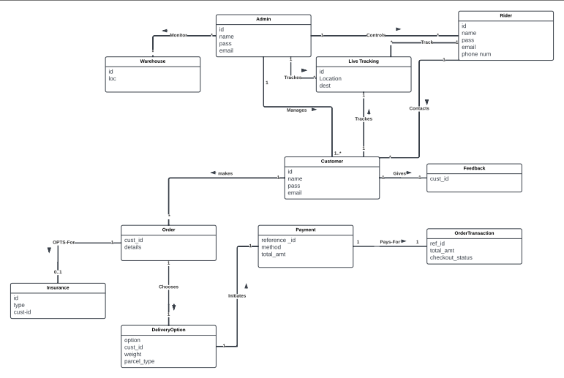

**9)Class Diagram**

**10)Sequence Diagram**

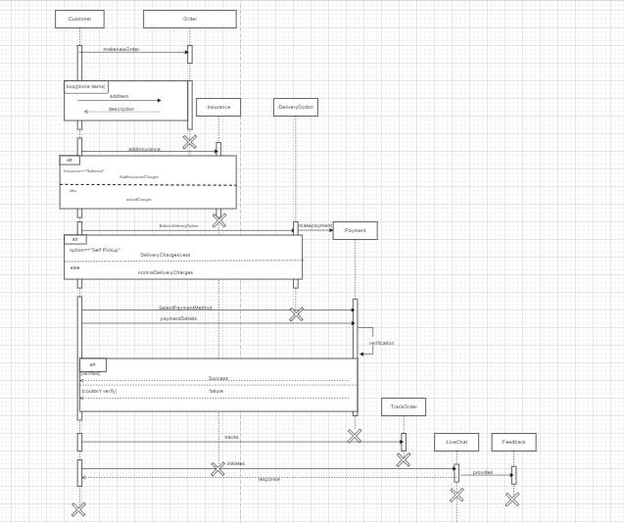

**11)Activity Diagram**

**12)State Chart Diagram**

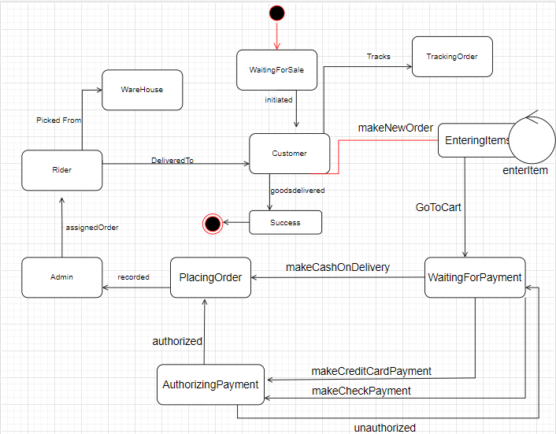

**13)Component Diagram**

**14)Package Diagram**

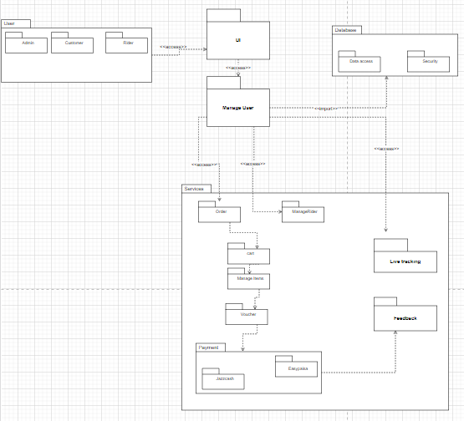

**15)Layered Diagram**

**16) Deployment Diagram**

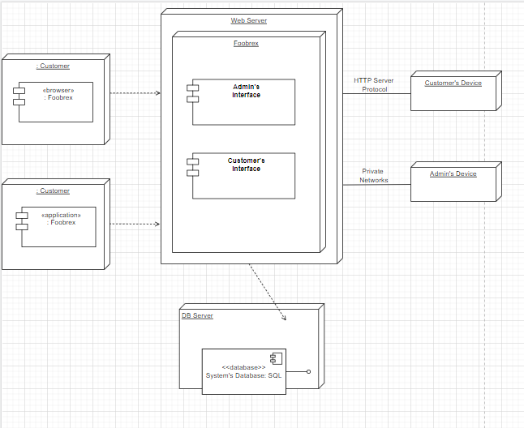

**17)Design Patterns**

**Grasp pattern**

Grasp pattern:

Example no 1 and 2(two grasp patterns ):

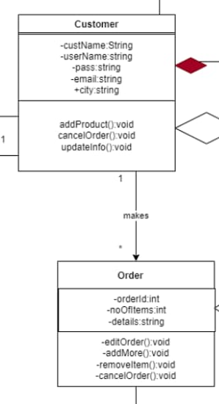

In this picture Customer class and order class **high cohesion and low coupling is used.**

**Furthermore, Creator instance is used here as customer creates an instance of order class.**

Example No 2:

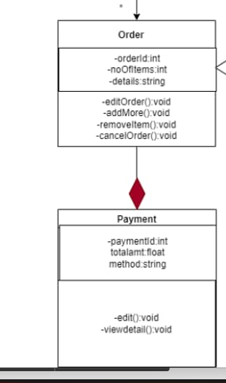

Here Information expert is used:

Order class assigns responsibility to the payment class for calculation of payment.